Top N and Bottom N analysis

Drag profit to the columns shelf and customer name to the rows shelf

Control Click on the Sum(profit) on the columns shelf and Drag it to the colors and the labels shelf.

As we want to show only the top and bottom 5 customers create two parameters

Top N

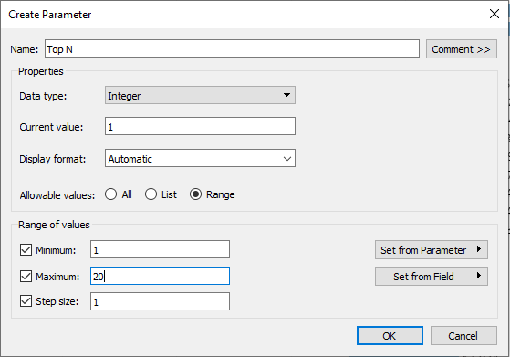

Bottom N

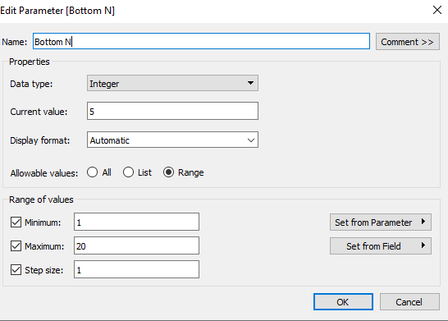

The show the parameter control

Create Two sets on the customer name as follows

Top N by Parameter

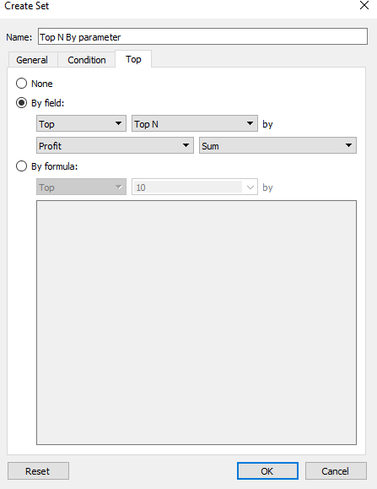

Bottom N by Parameter

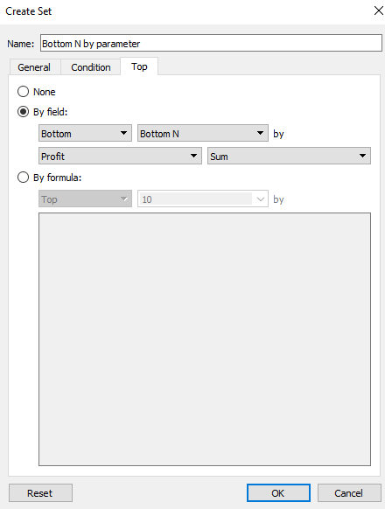

Control Click on Top N by parameter and Bottom N by parameter and click to create combined set and name it to Top and Bottom N by parameter

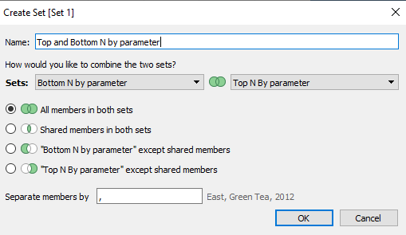

Drag the new set to the filters shelf.

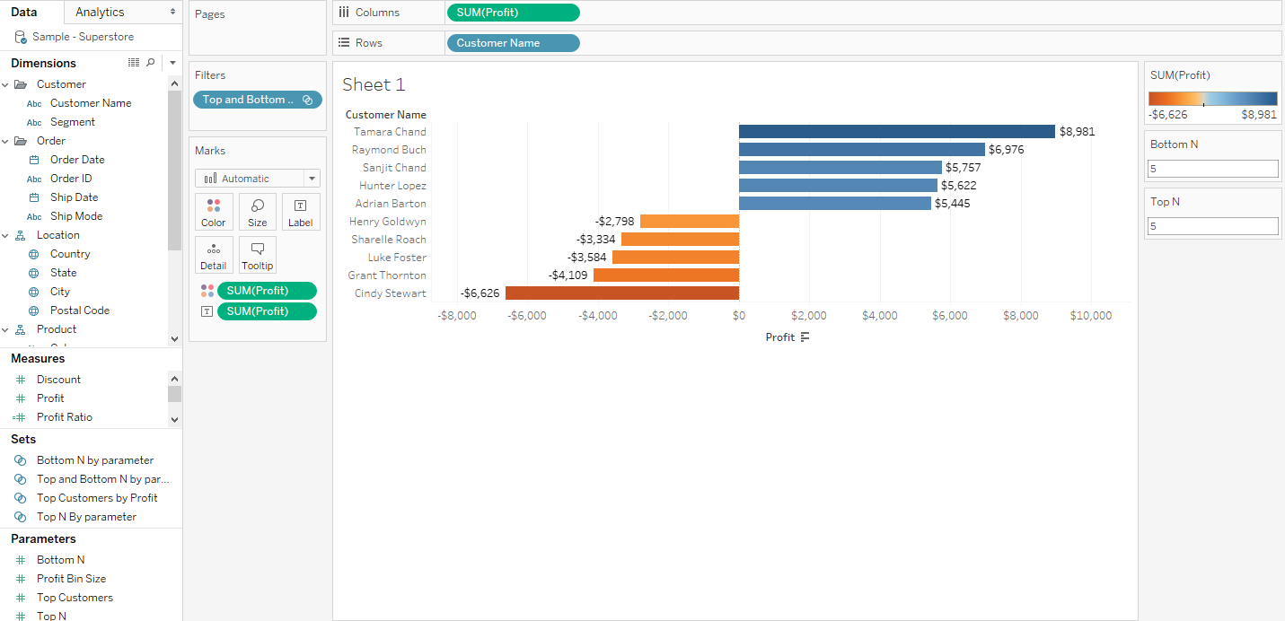

You can change the values in the parameter shelf.